Project essay
my project, was to make methods and create “art” with geometrical figures, I made methods to

create squares, rectangles, circles, triangle. First, I start off by taking the for loop that we made

from the beginning , this creates 500 (originally), but I set it to 100000, that way I can paint all

the canvas and also to make it select random colors in order have more colorful, all this

methods takes x and y values to place them at a certain position, however, the triangle does not.

The way the program starts is public void class that sets a tittle, length, width, and color the

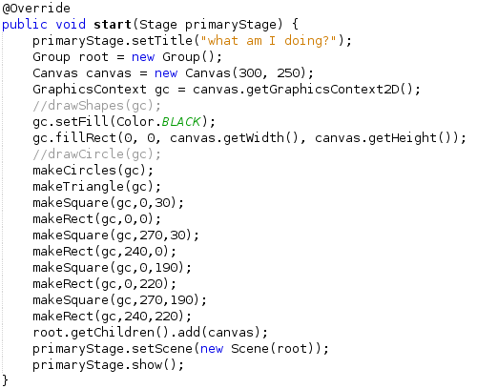
background as well as methods are called in this part.
Methods are called on this part
The canvas and tittle are made at this point

To breakdown more the program, make circles method creates 10000 with random x, y, and

colors. But before all of this happens it has to create one circle before creating the rest of the

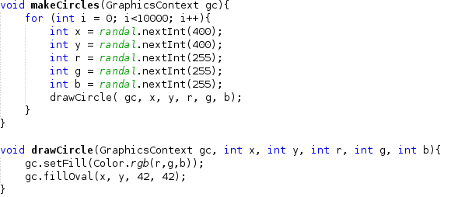
circle these are set this way
These values are integers that means their whole number and their make randomly by the for loop

This part happens after make circles methods

then it is followed by

